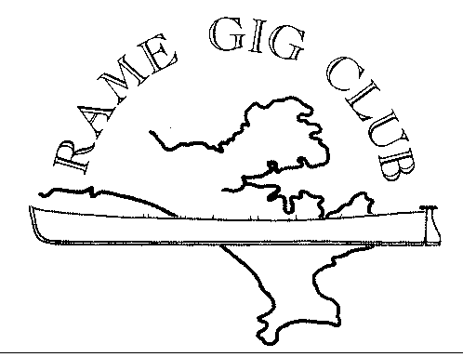

INFORMATION AND RULES FOR ANNUAL MOORING LICENSES IN CAWSAND BAY

Rame Gig Club has been authorised by the Queen's Harbour Master Plymouth, to issue licences for moorings in Cawsand Bay. Licences for the moorings may be made available if an appropriate application and payment have been made and approved by Rame Gig Club. All moorings must be laid and maintained in accordance with the following rules.

Rules:
- Membership - All holders of licences for mooring in the bay must either be members of Rame Gig Club or need to become Associated Members of Rame Gig Club. This year the cost is £25 and is payable on 1st January of each year or part year.
- Licence Fee - The current cost of a mooring licence is £35 per season and this is also payable on 1st January of each year or part year.
- Usage - The fees are payable regardless of usage of mooring during a season and cannot be transferred or sub let to other parties without written permission from Rame Gig Club.
- Location - Moorings must be laid in accordance with the following rules
  - GPS - If at all possible GPS location is to be supplied by applicant which will be plotted on QHM chart.
  - Distance - No moorings must be placed within a minimum of 40ft/12metres from any other existing moorings.
  - Approval - Prior to laying of moorings the Moorings Committee Member of the Rame Gig Club must be consulted to agree to the exact location of mooring.
  - Quantity of Boats - One boat only must be moored to the mooring.
- Actual Moorings:
  - Tackle - All tackle to be supplied by licensee and used at their own risk.
  - Strength - Should be of suitable strength for size of boat and conditions.
  - Maintained - Must be regularly maintained. It is essential that every two years they are lifted and cleaned to ensure no significant build up of mussels etc.
  - Markings - It must be clearly marked by number supplied by Rame Gig Club.
  - Buoys - All new buoys should be Yellow as specified and a suitable size
- Insurance - Necessary insurance must be maintained to ensure all claims made against you by others or damage to your boat or mooring from others is insured.
- Liability - No liability for loss of mooring tackle, craft, goods and/or equipment will be entered into and vessels are left at owner's risk. Rame Gig Club shall not be in any way responsible for damage caused under any circumstances and you are advised to find alternative mooring should the weather conditions require this.
RAME GIG CLUB SHALL NOT BE RESPONSIBLE IN ANY WAY FOR ANY DAMAGE RESULTING FROM YOUR USE OF A MOORING IN CAWSAND BY ANY CAUSE WHATSOEVER.

Please Read The Information And Rules For Annual Mooring Before Completing:
Name of Applicant
Address
Post Code
Telephone Daytime
Telephone Evening
Mobile
Email Address
Insurance Policy & Number
Name of Boat
Type of Boat (Fishing Etc.)
Length of Boat
Hull Colour
Ass. Club Membership - If not already a member fee £25.00
Annual Mooring Fee £35.00
Total Payable - Either £35.00 or £60.00
Buoy Number to be Allocated by Rame Gig Club

Declaration | I the under signed declare the necessary insurance is in place and I agree to adhere to the rules for the duration of the license.
Signature | Date
Once completed please forward this application to Mr. Dennis Hutchings, Tregoveryk, New Road, Kingsand, PL10 1PA
Payment may either be by Cheque payable to ‘Rame Gig Club’ or money transfer to Sort Code 20-50-40, Account No.83200078 (Please state the payee’s name and to what it relates).

